**Assignment --> 1**

**Guide to Setup Web Server Through AWS**

1. Firstly, enter in your AWS account via Root user or IAM user (https://aws.amazon.com/console/) .
2. Now we have to create instance.

Go to Services 🡪 Compute🡪EC2🡪Instances🡪Launch Instance.

1. Fill all basic details for creating instance:

* Name
* AMI (Amazon Machine Image) as Windows.
* Key Pair (Create New Key pair)

1. Our Instance is created Successfully.
2. Now go to the Instance and select that created instance then Click on connect.
3. Select RDP client 🡪download Remote Desktop File🡪Get Password🡪Upload Private Key🡪Decrypt Password
4. Copy the password and open RD File then input Password.
5. Your virtual machine is ready for use.
6. To setup Server turn off the firewall or windows defender.
7. Download Apache server file from browser.
8. After Downloading move Apache24 to C drive .
9. Then copy the path of bin folder to open httpd file through CMD (C:\Apache24\bin).
10. Open CMD and change path of current directory to above copied path of bin

C:\Users\Administrator>cd C:\Apache24\bin

C:\Apache24\bin>httpd -k install

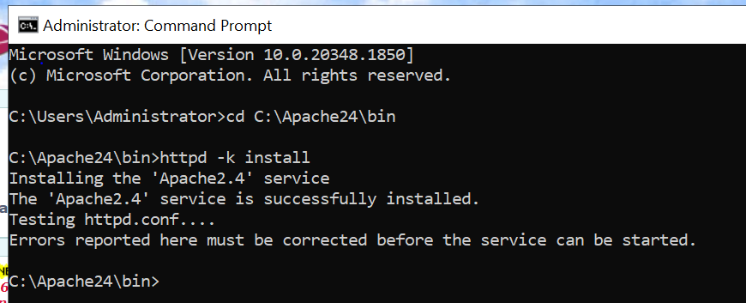

1. Now Apache is installed. We have to start it.
2. 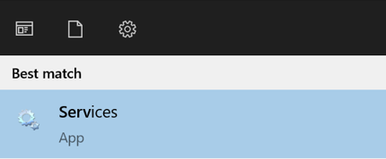Search services .
3. Now select Apache and start it.

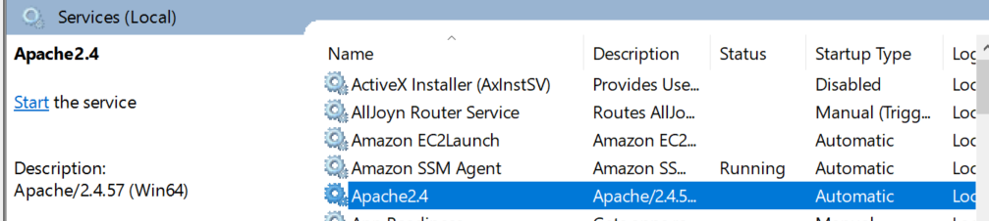

1. Open web browser and search 127.0.0.1

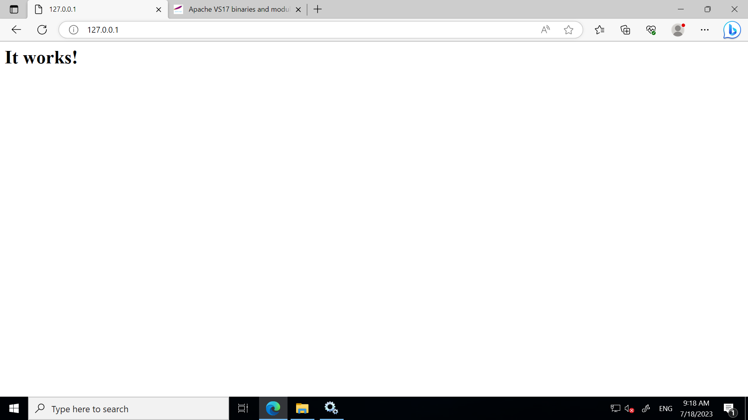

1. 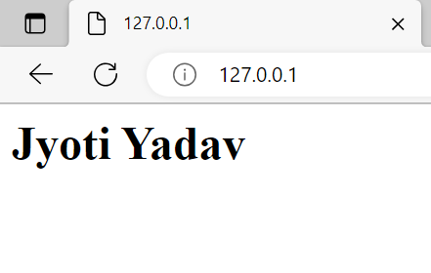Your web server is ready.